

INDIAN INSTITUTE OF INFORMATION TECHNOLOGY ALLAHABAD

Subject – Data Mining and Warehousing

Topic – Generalization ability of SVM classification based on Markov Sampling

Report By -

IIT2018108 – Ravi Kumar Sharma

Assignment :

You have to understand the algorithm proposed in the paper "Generalization ability of SVM classification based on Markov Sampling ''.
Run the algorithm on the shared pascal and Letter dataset and show the accuracy in terms of the attached image table: (make one more column in the last name MS_SVM with the new algorithm and give the result.
Try to run the algorithm using different kernels as given in the above table.
1) http://host.robots.ox.ac.uk/pascal/VOC/voc2012/ - pascal
2) https://archive.ics.uci.edu/ml/datasets/Letter+Recognition – letter

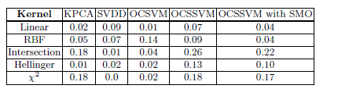

Introduction :

SVM – Support Vector Machine is one of the most widely used machine learning algorithm for classification problems in particular for classifying high-dimensional data. Besides their good performance in practical applications they also a good theoretical justification in terms of both universal consistency and learning rates.

Algorithm :

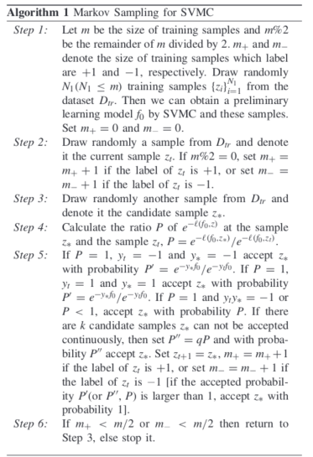

Result :

